Customization of Django Admin Interface.
Ref Website:- 1. https://rajansahu713.medium.com/customization-of-django-admin-interface-312b4a3c0f84
2. https://www.section.io/engineering-education/customizing-django-admin/

1. How can we change the header of the Admin Panel.
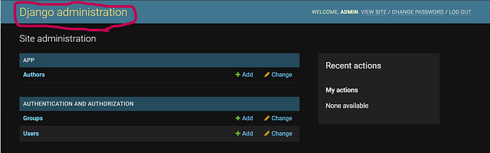
- As you can see from the above image Django provides the default header as ‘Django administration’.
- And we will see how to change it to ‘Admin Customization’
- To change the header of the Admin Panel we need to make some changes in the urls.py file of the project as you can see from the below Scripts.

#admincustom/urls.py
from django.contrib import
admin from django.urls import path # Add this it change the header of the admin panel.
admin.site.site_header = 'Admin Customization'urlpatterns = [
path('admin/', admin.site.urls),
]

Now we can see, that the header of the admin panel has been changed to Admin Customization.
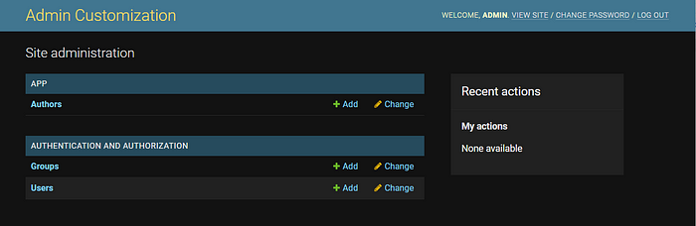
I think you all are enjoying this customization of the admin panel and let's move forward to change the admin panel.

2. How can we change the Admin Site Title of the admin Panel
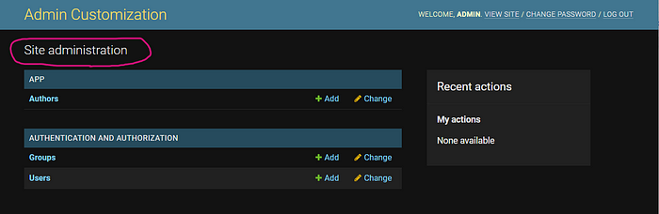
- By looking at the above image you all already understand what we will change.
- For changing the Site Title of the Admin Panel we need to follow the same step as we did in header changing.
- Open the urls.py file of the project and add admin.site.index_title as we are doing in the below scripts.
- #admincustom/urls.py
from django.contrib import admin
from django.urls import pathadmin.site.site_header = 'Admin Customization'
#Add the below line
admin.site.index_title = 'Customization App'urlpatterns = [
path('admin/', admin.site.urls),
]

Now we can see, that the Site Title of the admin panel has been changed to Customization App as below image.
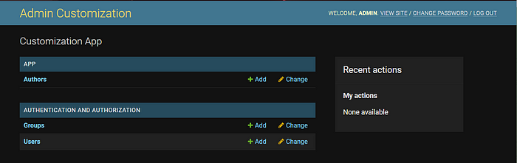

3. How to register the model in the admin Panel.
- Most of you know how to register a model in Admin Panel.
- But Here we will divide the fields into the sub-section.
Let's first create a model
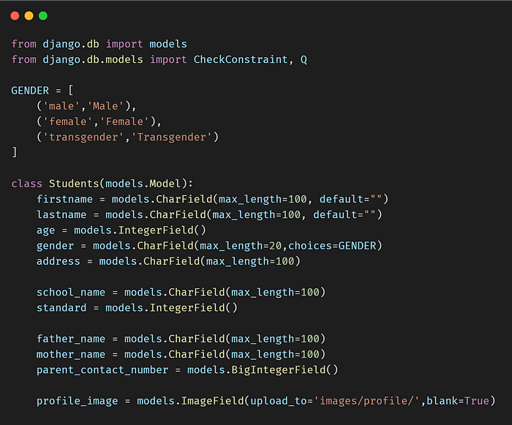
- The student's table has been created.
- Let's register this model in the Admin panel
- For that, we need to add the below scripts admin.py file of the project.
#admin.pyfrom django.contrib import admin
from .models import Students@admin.site(Students)
class StudentAdmin(admin.ModelAdmin):
passs
- After registering it in the admin panel it will look like as below while entering the data in the admin panel.
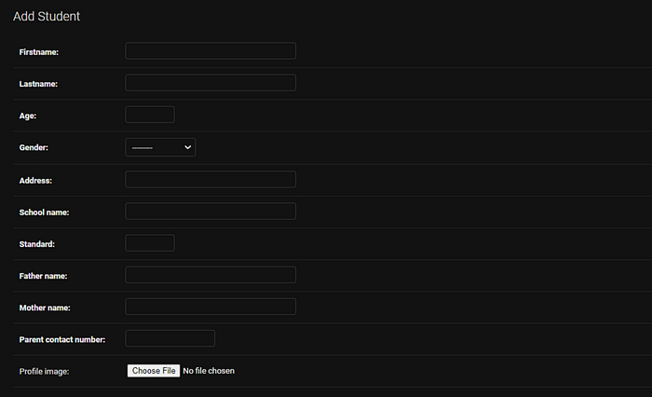
- Suppose we need to do fields in sub-sections while entering the data from Django Admin eg.
- Personal Informations section we include (firstname, lastname, age, gender, address, profile_image) fields
- School Details section (school_name, standard) fields.
- Parent Details section (father_name, mother_name, parent_contact_number) fields.
The above scenario can achieve with the help of fieldsets.
@admin.register(Students)
class StudentAdmin(admin.ModelAdmin):fieldsets = (
('Personal Informations', {
'fields': ('firstname', 'lastname', 'age',
'gender','address','profile_image')
}),('School Details', {
'classes': ('wide',),
'fields': ('school_name', 'standard'),
}),('Parent Details', {
'classes': ('wide',),
'fields': ('father_name','mother_name','parent_contact_number'),
}),
)
- Add the above code in the admin.py
- Now when we will insert the data in the admin it will look as below.
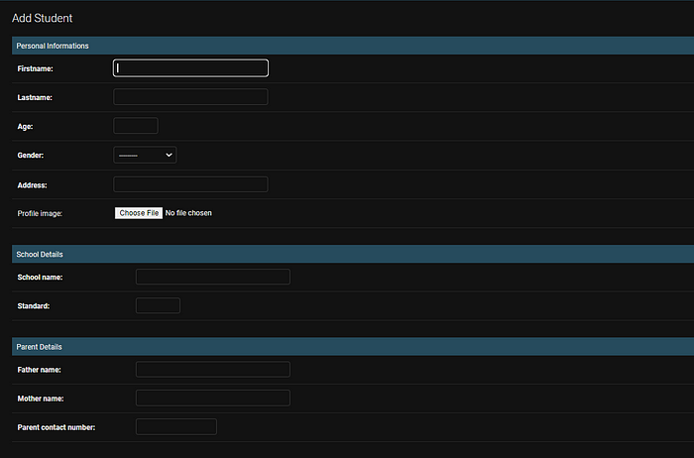

4. Change the model class name in Django admin interface.
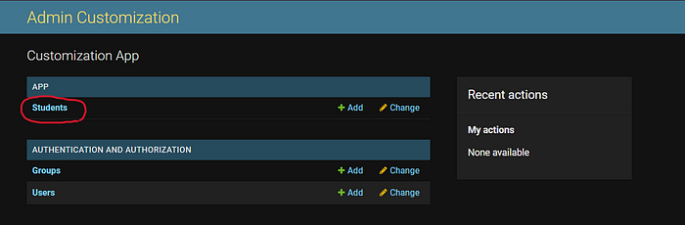
- Whenever we register a model in the admin.py file of an APP, It will appear in the Django admin interface as you can see from the above image.
- Suppose you wanted to show the student model as Student details in the admin interface.
- So for that, you need to mention it while creating the table like we did in the below code snippet.
class Student(models.Model):
# ... fields ...
# Add class meta
class Meta:
verbose_name = "Student Detail"
verbose_name_plural = "Student Details"

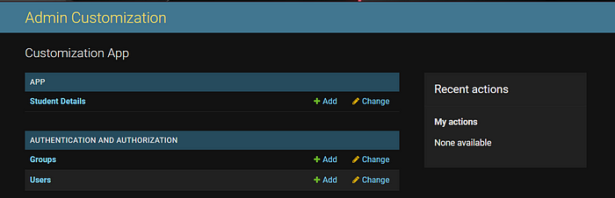

5. How to change app name in Django admin interface.
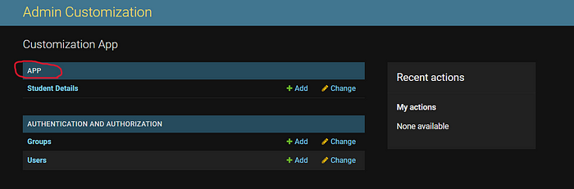
- By looking at the above I think you all may the idea what we are going to change.
- Suppose I wanted to give APP name to Student APP.
- For that, I need to add verbose_name to apps.py file of the APP.

from django.apps import AppConfig
class AppConfig(AppConfig):
name = 'app'
#Add this
verbose_name = "Student APP"

Now, check out the below image.
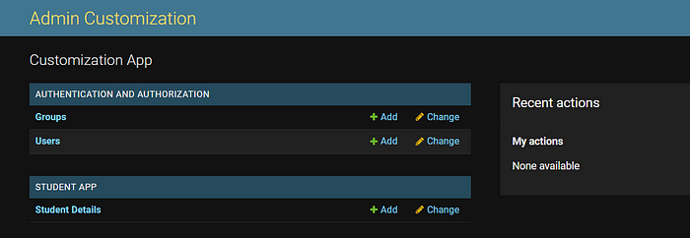

3. Removing the default groups
Let’s say, we want to get rid of the Groups app found in our Django admin site by default.
We will go ahead and import it then unregister it in admin.py.
from django.contrib.auth.models import Group # new
#...
admin.site.unregister(Group) # new

